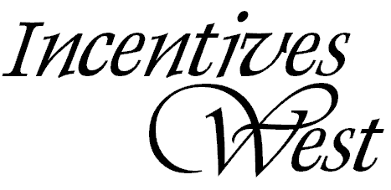
www.incentiveswest.com CO April 1, Twenty Ten

Celebrating 10 years of Ideas to Grow your Business

Incentives West (asi/822957, ppai/224617, UPIC/IDEAWEST) We are in Business to Grow your Business

Global Miniatures www.globalminiatures.com  3058 Ranchview Ln N, Plymouth, MN 55447  800.931.0535 • Fax: 763.476.8187  PPAI 238800 UPIC GLOBMIN ASI 57575  Molly Wheatley, Molly@GlobalMiniatures.com  Natural Trends www.naturaltrends.com  63 North 400 West, Provo, UT 84601  800.753.9591 • Fax: 801.221.4755  PPAI 235352 UPIC NTrends ASI 73497  A-J: Angela Lopez, angela@Naturaltrends.com  K-Z: Linda Foulke, linda@Naturaltrends.com  Fox Laminating http://www.foxlaminating.com  84 Custer St  West Hartford, CT 06110-1955  800.433.2468 • Fax: 860.953.1277  PPAI 113740 UPIC FOX0001 ASI 55230 ARA 21711 | Sports Systems Bag Corp. www.sscbags.com  44 Hazel Street Woonsocket, RI 02895  800.333.7225 • Fax: 401.767.3968  Customer Service SSCBAGS@yahoo.com  PPAI 241517 UPIC SSCBAGS SAGE 60354 ASI 88782  HPC Global www.hpcglobal.com  PO Box 503, Hanover, PA 17331  800.233.4463 • Fax: 800.528.7926  PPAI 113506 UPIC HPCG ASI 58805  Laura Yingling, laurayingling@hpcglobal.com  Product info: hpc@hpcglobal.com  Art: artroom@hpcglobal.com  Mobile Edge  www.mobileedge.com/corporate-incentives/  1150 N Miller St  Anaheim, CA 92806  714.399.1410 • Fax: 714.399.1401  PPAI 312937 UPIC Mobile ASI 71854
Your IW contacts are:

Jodi Spangrud for N CA, N NV, AZ and Key accounts jspangrud@incentiveswest.com 925.785.8375

Mark Shinn, MAS S CA,NW, HI, CO,UT,NM mshinn@incentiveswest.com Toll Free: 866.601.8958

